### What is a

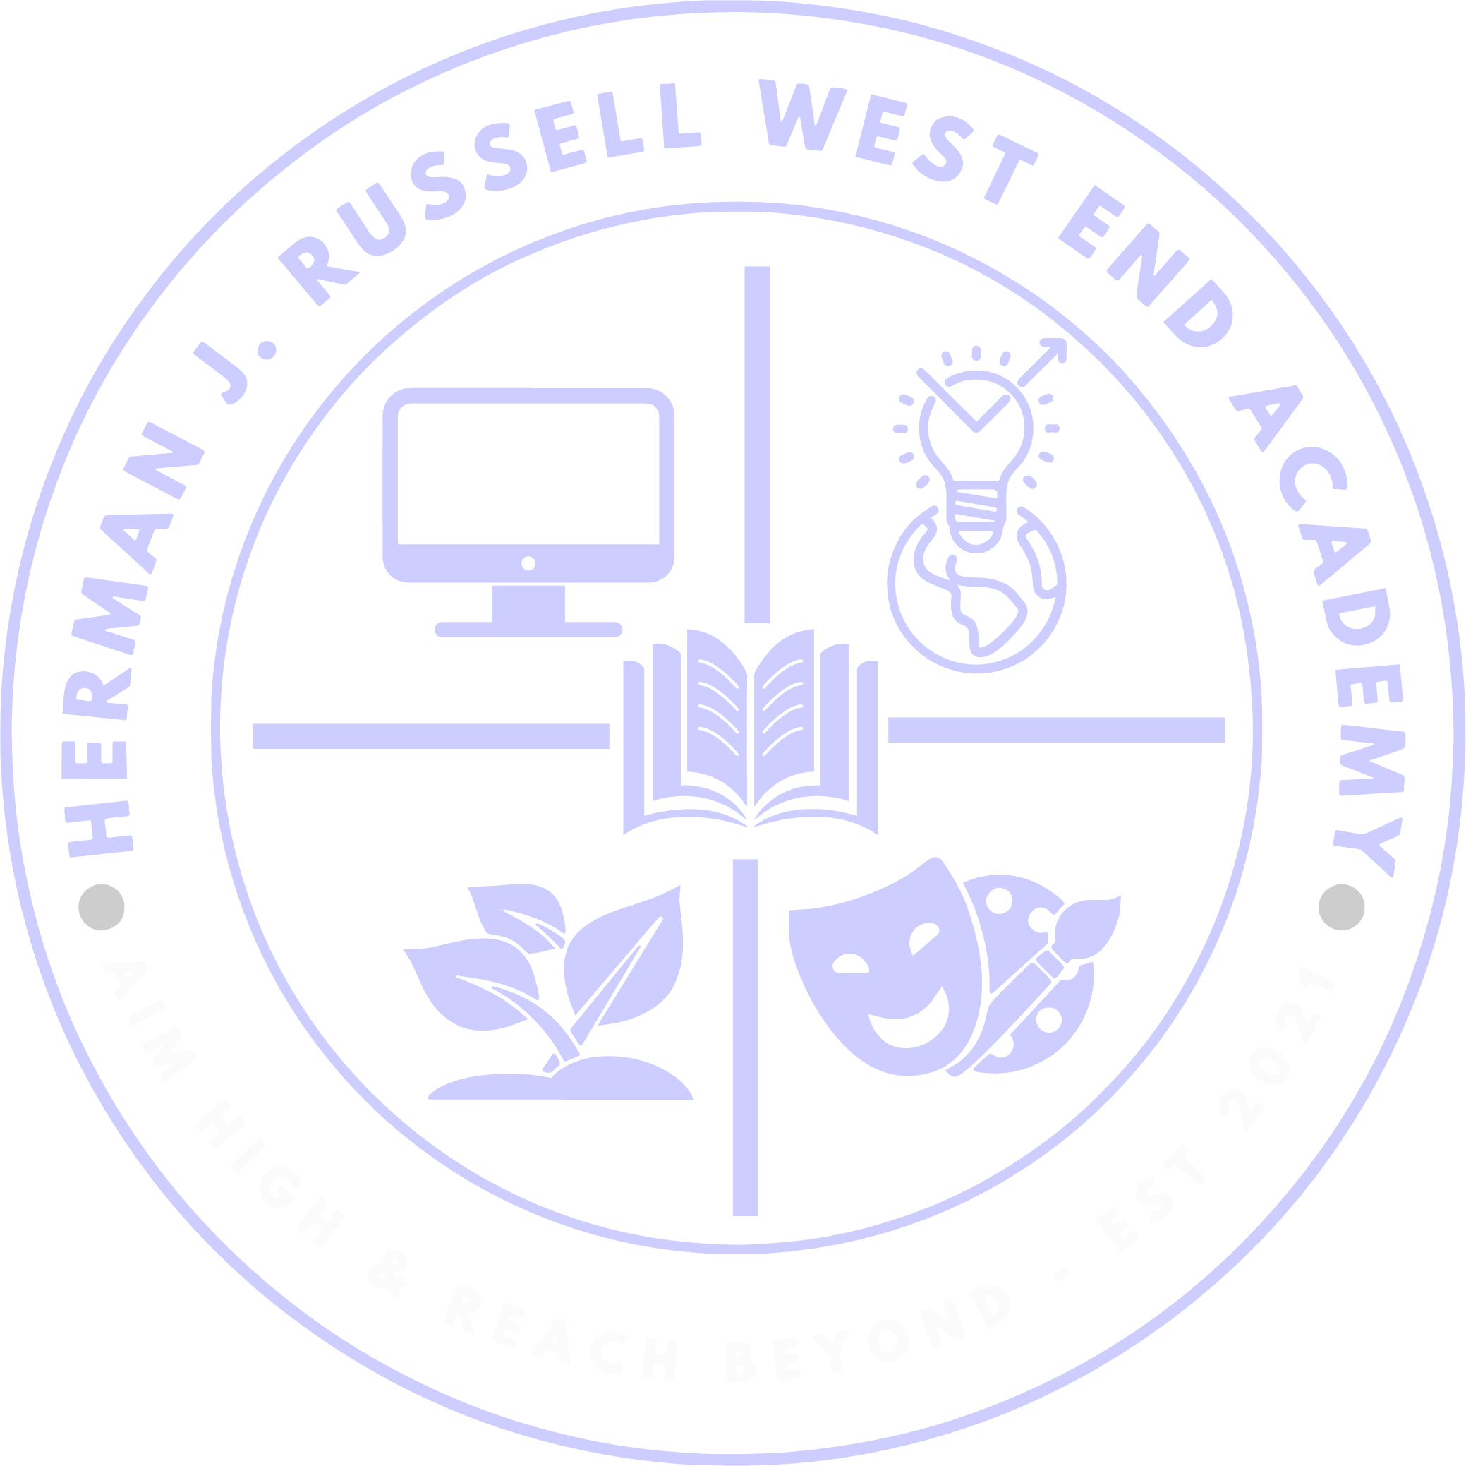

***School-Parent Compact?***

It is an agreement that explains how parents, teachers and students work together to make sure all our students reach grade-level standards and are successful. The compacts are reviewed and updated annually based on feedback from parents/guardians, students and teachers during the school wide Planning meeting and the Annual Title I

meeting. A copy of the school-parent compact brochure is distributed to every family to use as a guide during the year.

## Jointly Developed

The parents, students, and staff of **Herman J. Russell West End Academy** developed this School-Parent Compact for Success. Teachers identified individual needs and strategies, parents presented ideas to increase parental involvement which helps all stakeholders, and students shared their ideas for success.

## Volunteer Opportunities

If you would like to volunteer or participate in any parent engagement activities, contact Lelitia Lane, Parent Liaison at 404-802-6800 or [Lelitia.lane@atlanta.k12.ga.us](mailto:Lelitia.lane@atlanta.k12.ga.us)

# Activities to Build Partnerships

* Quarterly stakeholder meetings
* Mentor/Mentee Lunch & Learn
* Community Volunteer Day

# Promoting Student Learning

Attend and participate in the various academic workshops facilitated by Instructional coaches, parent liaison, as well as students; volunteer day; hall monitor

**Herman J. Russell West End Academy** is committed to continuous two-way communication with families about students’ learning. We do so by the following:

* + Parent Portal updates
  + Website updates
  + Flyers, emails, robo and personalized phone calls, face to face contact regarding academics and other events
  + Parent-Teacher conferences
  + Text messages, twitter, Facebook
  + Parent center board

**Questions about your child’s progress?**

Contact your child’s teacher by phone at

404-802-6800 or e-mail. E-mail addresses are on the school website under the “Let’s Stay Connected” Tab

School-Parent Compact for Achievement 2023-2024

***Herman J. Russell West End Academy***

#### Tonetta Green, Principal

[*http://www.atlanta.k12.ga.us/Domain/782*](http://www.atlanta.k12.ga.us/Domain/782)

#### 404-802-6806

***Revised: May 3, 2023***

***District Goals***

**Mission**

**Through a caring culture of equity, trust, collaboration, every student will graduate ready for college, career, and life.**

**Vision**

**A high performing**

**school district where students love to learn, educators inspire, families engage, and the community trust the system.**

# Our Goals for Student Achievement

*Herman J. Russell West End Academy Goals*

**Achievement Gap:**

To improve overall student achievement Herman J. Russell West End Academy will focus on narrowing the achievement gap between Regular Ed students and Special Ed students.

## In the Classroom

The teachers will work with students and their families to support students’ success in all content areas.

##### Some of our key connections with families will be:

* Parent/teacher conferences & parent shadowing to provide the needed resources to empower parent/guardians with skills to assist their child with homework, as well as learn themselves. Meeting via phone.
* Identify student’s individual

needs & implement research based instructional strategies.

## At Home

**Herman J. Russell West End Academy** parents are encouraged to become and remain actively involved in their child/children’s education.

##### Parents can/will:

* Participate in student’s homework activities/discussions to ensure that he/she does well on the Georgia Milestone.
* Check student’s progress on parent portal and parent/teacher conferences to ensure that my child is on target and progressing.

***Teachers, Parents & Students - Together for Success***

**Our Scholars**

**Herman J. Russell West End Academy** students regularly discuss with staff and parents’ ways they can succeed in school academically and socially. Some student ideas and suggestions are:

* Actively participate in class and work with my teachers and other resources to ensure academic success.
* Showcase my abilities to parents/guardians through projects.
* Participate in tutorials and extra- curricular activities that will enhance my ability to do well in math, science, social studies, and language arts, and promote academic excellence.

